Avalon Threading
By Tyler Barton and Nick Kramer

When we created Avalon, we worked very hard to save developers from the difficulties of threading. As a result, the vast majority of Avalon programmers will never have to write an interface that uses more than one thread. This is great since multi threaded programs are complex and difficult to debug. They should be avoided when single threaded solutions exist.

No matter how well architected, no UI framework will ever be able to provide a single threaded solution for every sort of problem. Avalon comes close, but there are still situations where multiple threads improve GUI responsiveness or application performance. After discussing some background material, this paper will explore some of these situations. We’ll finish with a discussion of some lower level details for the particularly curious.

Avalon Threading Overview
Typical Avalon applications start their lives with two threads, one for handling rendering and another for managing the UI. The rendering thread effectively runs hidden in the background while the UI thread receives input, handles events, paints the screen and runs application code. Most applications use a single UI thread, although in some situations it’s best to use several. We’ll discuss this with an example later in the paper.

The UI thread queues work items inside an object called a dispatcher. The dispatcher selects work items on a priority basis and runs each one to completion. Every UI thread must have at least one dispatcher and each dispatcher can execute work items in exactly one thread.

The trick to building responsive, friendly applications is to maximize the dispatcher throughput by keeping the work items small. This way items never get stale sitting in the dispatcher queue waiting for processing. Any perceivable delay between input and response can frustrate a user.

How then are Avalon applications supposed to handle big operations? What if my code involves a large calculation or needs to query a database on some remote server? Usually the answer is to handle the big operation in a separate thread, leaving the UI thread free to tend to items in the dispatcher queue. When the big operation completes, it can report it’s result back to the UI thread for display.

If there were no complications, and this process were as easy as it sounds we wouldn’t need to publish this paper. Historically, Windows only allows user interface elements to be accessed by the thread that created them. This means that a background thread in charge of some long running task can’t just dump its findings in a textbox when it’s done. Windows does this to ensure the integrity of UI components. A listbox could turn out looking very strangely if it’s contents were updated by a background thread during painting.

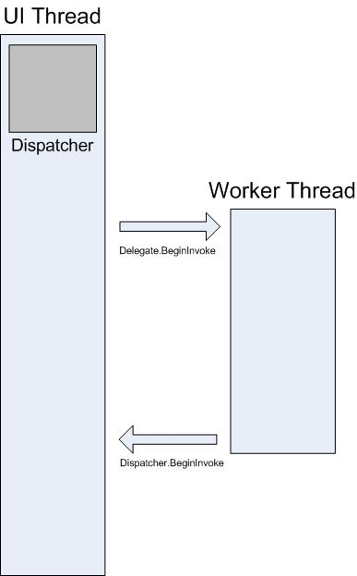
Avalon has a built in mutual exclusion mechanism that enforces this. Just about every class in Avalon descends from DependencyObject. At construction, a dependency object stores a reference to the dispatcher linked to the currently running thread. In effect, the dependency object associates with the thread that creates it. During program execution, a dependency object can call its public VerifyAccess method. VerifyAccess examines the dispatcher associated with the current thread and compares it to the dispatcher reference stored during construction. If they don’t match, VerifyAcess throws an exception. VerifyAccess is intended to be called at the beginning of every method belonging to a dependency object.

With a guarantee that only one thread will ever access our components we don’t have to worry about writing thread safe code. This saves time and prevents problems, but it also makes it difficult to use multiple threads in a graphical application. If only one thread can modify the UI how do background threads interact with the user?

A background thread can ask the UI thread to perform an operation on its behalf. It does this by registering a work item with the dispatcher of the UI thread. The dispatcher class provides two methods for registering work items: Invoke and BeginInvoke. Both methods schedule a delegate for execution. Invoke is a synchronous call – that is, it doesn’t return until the UI thread actually finishes executing the delegate. BeginInvoke is asynchronous and returns immediately.

public DispatcherOperation BeginInvoke(DispatcherPriority, delegate);
public object Invoke(DispatcherPriority, delegate);

We will demonstrate these methods in the examples that follow.

Dispatcher Priorities
As mentioned earlier, the dispatcher orders the elements in its queue by priority. There are ten levels that may be specified when adding an element to the dispatcher queue. These priorities are maintained in the System.Windows.Threading.DispatcherPriority enumeration. Detailed information about dispatcher priority levels can be found in the SDK documentation.

Priority levels fall into three categories: foreground, input and background. In this paper, we will use two key priority levels that are worth mention. DispatcherPriority.Send is the highest possible level. Events scheduled at this priority will be executed immediately. Conversely, events scheduled at DispatcherPriority.SystemIdle will only be executed when the queue is otherwise empty.

Threads in Action

A Single Threaded Application with a Long Running Calculation
Most graphical user interfaces spend most of their time idle, waiting for a user generated event. With a little careful programming, this idle time can be used constructively without affecting the responsiveness of the user interface. The Avalon threading model doesn’t allow input to interrupt an operation happening in the UI thread. This means we must be sure to return to the dispatcher periodically to process pending input events before they get stale.

Consider the following example.

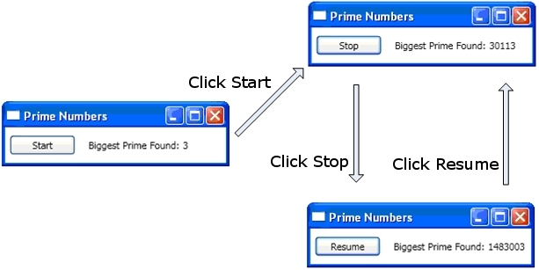

This simple application counts upwards from 3 searching for prime numbers. When the user clicks the start button, the search begins. When the program finds a prime, it updates the user interface with its discovery. At any point, the user can stop the search.

Although simple enough, this problem presents some difficulties. The prime number hunt could go on forever. If we handled the entire hunt inside of the start button’s “click” event handler, we would never give the UI thread a chance to handle other events. The interface would be unable to respond to input and process messages from Windows. It would never repaint and never service button clicks.

We could conduct the prime number search in a separate thread, but then we would have to deal with synchronization issues. With a single threaded approach we can directly update the label listing the largest prime found.

If we break up the task of calculation into manageable chunks we can periodically return to the dispatcher and process events. We can give Avalon an opportunity to repaint and process input.

The best way to split processing time between calculation and event handling is to manage calculation from the dispatcher. Using Dispatcher.BeginInvoke, we can schedule prime number checks in the same queue UI events are drawn from. In our example, we will schedule only a single prime number check at a time. After the prime number check completes we will schedule the next check immediately. This check will proceed only after pending UI events have been handled.

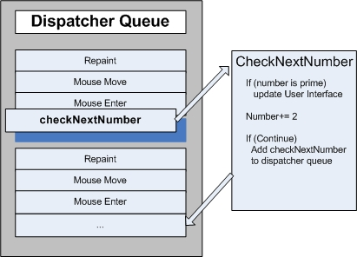

Microsoft Word accomplishes spell checking using this mechanism. Spell checking is done in the background using the idle time of the UI thread.
Here’s the code

First the XAML:
<Window x:Class="AvalonApplication1.Window1"
xmlns="http://schemas.microsoft.com/winfx/avalon/2005"
xmlns:x="http://schemas.microsoft.com/winfx/xaml/2005"
Text="Prime Numbers" Width="260" Height="75"
>

<StackPanel Orientation="Horizontal" VerticalAlignment="Center" >
<Button Content="Start" Click="startOrStop" ID="mybutton" Margin="5 0 5 0"/>
<TextBlock Margin="10 5 0 0">Biggest Prime Found:</TextBlock>
<TextBlock ID="bigPrime" Margin="4 5 0 0">3</TextBlock>
</StackPanel>

</Window>

using System;
using System.Threading;
using System.Windows;
using System.Windows.Controls;

namespace AvalonApplication1
{
public delegate void nextPrimeDelegate();
public partial class Window1 : Window
{
private long num = 3; //Current number to check
private bool continueCalculating = false;

public Window1() : base()
{InitializeComponent();}

public void startOrStop(object sender, EventArgs e)
{
if (continueCalculating)
{
continueCalculating = false;
mybutton.Content = "Resume";
}
else
{
continueCalculating = true;
mybutton.Content = "Stop";
mybutton.Dispatcher.BeginInvoke(System.Windows.Threading.DispatcherPriority.Send, new nextPrimeDelegate(this.checkNextNumber));
}
}

public void checkNextNumber()
{
for (long i = 3; i <= Math.Sqrt(num); i++)
{
if (num % i == 0)
{
goto NotAPrime;
}
}
bigPrime.TextContent= num.ToString();

NotAPrime:
num += 2;
if (continueCalculating)
{
mybutton.Dispatcher.BeginInvoke(System.Windows.Threading.DispatcherPriority.SystemIdle, new nextPrimeDelegate(this.checkNextNumber));
}
}
}
}

public void startOrStop(object sender, EventArgs e)
{
if (continueCalculating)
{
continueCalculating = false;
mybutton.Content = "Resume";
}
else
{
continueCalculating = true;
mybutton.Content = "Stop";
mybutton.Dispatcher.BeginInvoke(
System.Windows.Threading.DispatcherPriority.SystemIdle,
new nextPrimeDelegate(this.checkNextNumber));
}
}

This is the event handler for the button. Besides updating the text on the button, this handler is responsible for scheduling the first prime number check by adding a delegate to the dispatcher queue. Sometime after this event handler has completed, the dispatcher will select this delegate for execution.

As we mentioned earlier, BeginInvoke is the dispatcher member used to schedule a delegate for execution. In this case, we choose the SystemIdle priority. The dispatcher will only execute this delegate when there are no important events to process. UI responsiveness is more important than number checking. We also pass a new delegate representing our number checking routine.

public void checkNextNumber()
{
for (long i = 3; i <= Math.Sqrt(num); i++)
{
if (num % i == 0)
{
goto NotAPrime;
}
}
bigPrime.TextContent= num.ToString();

NotAPrime:
num += 2;
if (continueCalculating)
{
mybutton.Dispatcher.BeginInvoke(
System.Windows.Threading.DispatcherPriority.SystemIdle,
new nextPrimeDelegate(this.checkNextNumber));
}
}
This function checks if the next odd number is prime. If it is prime, the function directly updates the bigPrime textBlock to reflect its discovery. We can do this because the calculation is occurring in the same thread that was used to create the component. Had we chosen to use a separate thread for the calculation, we would have to use a more complicated synchronization mechanism and execute the update in the UI thread. We’ll demonstrate this situation next.

Handling a Blocking Operation with a Background Thread

Handling some blocking operations in a graphical application can be sticky. We don’t want to call blocking functions from event handlers because the application will appear to freeze up. We can use a separate thread to handle these operations, but when we’re done, we have to synchronize with the UI thread, since we can’t directly modify the gui from our worker thread. We can use Invoke or BeginInvoke to insert delegates into the dispatcher of the UI thread. Eventually these delegates will be executed with permission to modify UI elements.

In this example we will mimic a remote procedure call that retrieves a weather forecast. We’ll use a separate worker thread to execute this call, and we’ll schedule an update function in the dispatcher of the UI thread when we’re done.

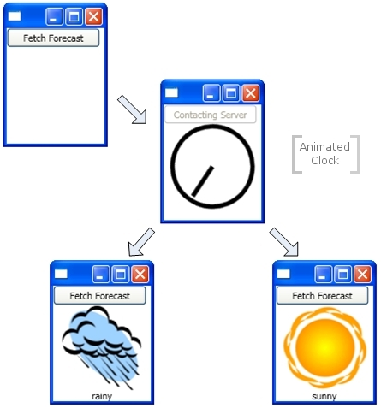

using System;
using System.Windows;
using System.Windows.Controls;
using System.Windows.Data;
using System.Windows.Documents;
using System.Windows.Media;
using System.Windows.Shapes;
using System.Threading;

namespace background_task
{
public partial class Window1 : Window
{
private delegate void NoArgDelegate();
private delegate void OneArgeDelegate(String arg);

public Window1()
: base()
{
InitializeComponent();
//Make sure the animation starts paused
FindStoryboardClock(rotateClock).ClockController.Pause();
}

private void forecastButtonHandler(object sender,
RoutedEventArgs e) {

//Change the status image and start the rotation animation
FindStoryboardClock(rotateClock).ClockController.Begin();
tomorrowsWeather.Fill =
(DrawingBrush)topWindow.Resources["timerBrush"];

fetchButton.IsEnabled = false;
fetchButton.Content = "Contacting Server";
weatherText.TextContent = "";

//Start fetching the weather forecast asynchronously
NoArgDelegate fetcher =
new NoArgDelegate(this.fetchWeatherFromServer);
fetcher.BeginInvoke(null, null);
}

private void fetchWeatherFromServer()
{
//simulate the delay from network access
Thread.Sleep(4000);

//Tried and true method for weather
//forecasting - random numbers!

Random rand = new Random();
String weather;
if (rand.Next(2) == 0)
{
weather = "rainy";
}
else
{
weather = "sunny";
}

//Schedule a the update function in the UI thread
OneArgeDelegate weatherUpdater = new OneArgeDelegate(updateUserInterface);
tomorrowsWeather.Dispatcher.BeginInvoke(
System.Windows.Threading.DispatcherPriority.Send,
weatherUpdater, weather
);
}

private void updateUserInterface(String weather)
{
FindStoryboardClock(rotateClock).ClockController.Stop();
if (weather == "sunny")
{
tomorrowsWeather.Fill = (ImageBrush)topWindow.Resources["sunBrush"];
}
else if (weather == "rainy")
{
tomorrowsWeather.Fill = (ImageBrush)topWindow.Resources["rainBrush"];
}
fetchButton.IsEnabled = true;
fetchButton.Content = "Fetch Forecast";
weatherText.TextContent = weather;
}

}
}

- The Button Handler
private void forecastButtonHandler(object sender, RoutedEventArgs e)
{
//Change the status image and start the rotation animation
FindStoryboardClock(rotateClock).ClockController.Begin();
tomorrowsWeather.Fill =
(DrawingBrush)topWindow.Resources["timerBrush"];

fetchButton.IsEnabled = false;
fetchButton.Content = "Contacting Server";
weatherText.TextContent = "";

//Start fetching the weather forecast asynchronously
NoArgDelegate fetcher =
new NoArgDelegate(this.fetchWeatherFromServer);
fetcher.BeginInvoke(null, null);
}

When the button is clicked, we display the clock drawing and start animating it. We disable the button. We invoke fetchWeatherFromServer in a new thread, then we return, allowing the dispatcher to process events while we wait to collect the weather forecast.

- Fetching the Weather
private void fetchWeatherFromServer()
{
//simulate the delay from network access
Thread.Sleep(4000);

//Tried and true method for weather
//forecasting - random numbers!

Random rand = new Random();
String weather;
if (rand.Next(2) == 0)
{
weather = "rainy";
}
else
{
weather = "sunny";
}

//Schedule a the update function in the UI thread
OneArgeDelegate weatherUpdater =
new OneArgeDelegate(updateUserInterface);
tomorrowsWeather.Dispatcher.BeginInvoke(
System.Windows.Threading.DispatcherPriority.Send,
weatherUpdater, weather
);
}

To keep things simple, we don’t actually have any networking code in this example. Instead, we simulate the delay of network access by putting our new thread to sleep for four seconds. In this time, the original UI thread is still running and responding to events. To prove this to you, we’ve left an animation running. The minimize and maximize buttons also continue to work.

When the delay is finished, and we’ve randomly selected our weather forecast, it’s time to report back to the ui thread. We do this by scheduling a call to updateUserInterface in the UI thread using that thread’s dispatcher. We pass a string describing the weather to this scheduled function call.

3. Updating the UI
private void updateUserInterface(String weather)
{
FindStoryboardClock(rotateClock).ClockController.Stop();
if (weather == "sunny")
{
tomorrowsWeather.Fill =
(ImageBrush)topWindow.Resources["sunBrush"];
}
else if (weather == "rainy")
{
tomorrowsWeather.Fill =
(ImageBrush)topWindow.Resources["rainBrush"];
}
fetchButton.IsEnabled = true;
fetchButton.Content = "Fetch Forecast";
weatherText.TextContent = weather;
}

When the dispatcher in the UI thread has time, it will execute the scheduled call to updateUserInterface. This method stops the clock animation, and chooses an image to describe the weather. It displays this image, and restores the “fetch forecast” button.
Multiple Windows, Multiple Threads
Some Avalon applications will require multiple top level windows. It’s perfectly acceptable for one thread/Dispatcher team to manage multiple windows, but sometimes several threads do a better job. This is especially true if there’s any chance that one of the windows will monopolize the thread.

Windows Explorer works in this fashion. Every new explorer window belongs to the original process, but is created under the control of an independent thread.

Using the windows forms integration API, we can embed the System.Windows.Forms.WebBrowser component in our Avalon app. We can very easily create a simple internet explorer substitute We’ll start with an important feature: the ability to open a new explorer window.

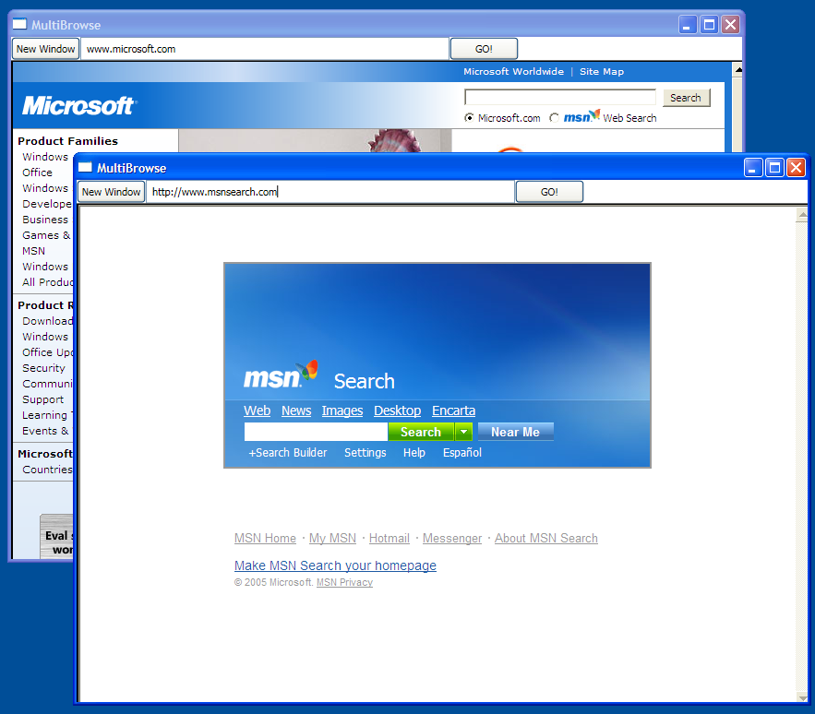

When the user clicks the “new window” button, we launch a copy of our window in a separate thread. This way long running or blocking operations in one WebBrowser component won’t lock all of its siblings.

In reality, the WebBrowser component has its own complicated threading model. We’ve chosen it because it should be familiar to most readers and it’s easy to believe that a web browser could monopolize the UI thread controlling it.

Here’s the code:
<Window x:Class="AvalonApplication4.Window1"
xmlns="http://schemas.microsoft.com/winfx/avalon/2005"
xmlns:x="http://schemas.microsoft.com/winfx/xaml/2005"
Text="MultiBrowse" Width="800" Height="600"
>

<StackPanel Orientation="Vertical">
<StackPanel Orientation="Horizontal">
<Button Content="New Window" Click="newWindowHandler"/>
<TextBox Name="newLocation" Width="400"/>
<Button Content="GO!" Click ="browse"/>
</StackPanel>
<Border Name="PlaceHolder" BorderThickness="2" BorderBrush="Black" Width="800" Height="550"/>
</StackPanel>
</Window>

using System;
using System.Windows;
using System.Windows.Controls;
using System.Windows.Data;
using System.Windows.Documents;
using System.Windows.Media;
using System.Windows.Shapes;
using System.Windows.Forms;
using System.Windows.Forms.Integration;
using System.Threading;

namespace AvalonApplication4
{
public partial class Window1 : Window
{
System.Windows.Forms.WebBrowser webBrowser; WindowsFormsHost host;

public Window1()
: base()
{
InitializeComponent();
host = new WindowsFormsHost();
webBrowser = generateBrowser();
host.AddChild(webBrowser);

//Fill in the blank space defined in XAML with our WindowsFormsHost
PlaceHolder.Child = host;
}

//Create a Browser component
private System.Windows.Forms.WebBrowser generateBrowser()
{
WebBrowser browser = new System.Windows.Forms.WebBrowser();
browser.Dock = System.Windows.Forms.DockStyle.Fill;
browser.Url = new System.Uri("http://www.msnsearch.com", System.UriKind.Absolute);
return browser;
}

//Handler for URL textbox entry
private void browse(object sender, RoutedEventArgs e)
{
webBrowser.Navigate(newLocation.Text);
}

private void newWindowHandler(object sender, RoutedEventArgs e)
{
Thread newWindowthread = new Thread(new ThreadStart(threadStartingPoint));
newWindowthread.ApartmentState = ApartmentState.STA;
newWindowthread.Start();
}

private void threadStartingPoint()
{
Window1 tempWindow = new Window1();
tempWindow.Show();
System.Windows.Threading.Dispatcher.Run();
}

}
}

Most of this code creates and web browser components or controls browsing. Only the threading segments are really interesting to us in the context of this paper.

private void newWindowHandler(object sender, RoutedEventArgs e)
{
Thread newWindowthread = new Thread(
new ThreadStart(threadStartingPoint));
newWindowthread.ApartmentState = ApartmentState.STA;
newWindowthread.Start();
}

This function is called when the “new window” button is clicked. It creates a new thread and starts it asynchronously.

private void threadStartingPoint()
{
Window1 tempWindow = new Window1();
tempWindow.Show();
System.Windows.Threading.Dispatcher.Run();
}

This method is the starting point for the new thread. We create a new window under the control of this thread. Avalon automatically creates a new dispatcher to manage our new thread. All we have to do to make our window functional is ask this dispatcher to start running.

Writing Components Using Threading

The NET Framework Developer's Guide describes a pattern for how a component can expose asynchronous behavior to its clients (http://msdn2.microsoft.com/en-us/library/wewwczdw.aspx). For instance, suppose we wanted to package the fetchWeatherFromServer() function into a reusable, non-graphical component. Following the standard .Net Framework pattern, this would look something like:
public class WeatherComponent : Component {
public string GetWeather();
public void GetWeatherAsync();
public event GetWeatherCompletedEventHandler GetWeatherCompleted;
}

public class GetWeatherCompletedEventArgs : AsyncCompletedEventArgs {
public string Weather { get; };
}

public delegate GetWeatherCompletedEventHandler(object sender, GetWeatherCompletedEventArgs e);

GetWeatherAsync would use one of the techniques described previously in this article, such as creating a background thread, to do the work asynchronously – i.e., not blocking the calling thread.

One of the most important parts of this pattern is calling the *Completed method on the same thread that called the *Async method to begin with. You could do this using WPF fairly easily, by storing away Dispatcher.Current – but then your non-graphical component could only be used in WPF applications, not in WinForms or ASP.Net programs. The SynchronizationContext class addresses this need – think of it as a simplified version of Dispatcher that works with other UI frameworks as well.

Using SynchronizationContext, our implementation would look something like:
using System;
using System.Windows;
using System.Threading;

namespace scratch
{
public class WeatherComponent2 : Component
{
public string GetWeather()
{
return fetchWeatherFromServer();
}

private SynchronizationContext requestingContext = null;
public void GetWeatherAsync()
{
if (requestingContext != null)
throw new InvalidOperationException("This component can only handle 1 async request at a time");

requestingContext = SynchronizationContext.Current;

NoArgDelegate fetcher = new NoArgDelegate(this.fetchWeatherFromServer);

// Launch thread
fetcher.BeginInvoke(null, null);
}

private void RaiseEvent(GetWeatherCompletedEventArgs e)
{
if (GetWeatherCompleted != null)
GetWeatherCompleted(e);
}

private void fetchWeatherFromServer()
{
// do stuff

GetWeatherCompletedEventArgs e = new GetWeatherCompletedEventArgs(weather);
SendOrPostCallback callback = new SendOrPostCallback(DoEvent);
requestingContext.Post(callback, e);
requestingContext = null;
}

public event GetWeatherCompletedEventHandler GetWeatherCompleted;
}

}

Technical Details and Stumbling Points

Nested Pumping
Sometimes it’s not feasible to completely lock up the UI thread. Let’s consider the MessageBox.Show function. MessageBox.Show doesn’t return until the user clicks the “ok” button. It does, however, create a window that must have a message loop in order to be interactive. While we’re waiting for the user to click “ok” the original application window does not respond to user input. It does, however, continue to process paint messages. You’ll notice that the original window redraws itself when covered and revealed.

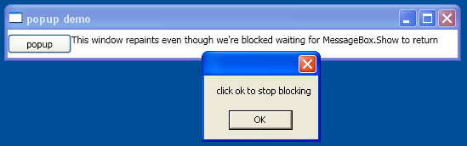

Some thread must be in charge of the popup. Avalon could create a new thread just for the popup, but this thread would be unable to paint the disabled elements in the original window (remember the mutual exclusion section from the beginning of the document). Instead, Avalon uses a nested message processing system. The Dispatcher class includes a special method called pushFrame. PushFrame stores an application’s current execution point then begins a new message loop. When the nested message loop finishes, execution resumes after the original pushFrame call.

In this case, pushFrame maintains the program context at the call to MessageBox.Show, and starts a new message loop to repaint the background window and handle input to the popup. When the user clicks “ok” and clears the popup, the nested loop exits and control resumes after the call to MessageBox.Show.

Stale Routed Events
The routed event system in Avalon notifies entire trees when events are raised.

<Canvas MouseLeftButtonDown="handler1" Width="400" Height="400">
<Ellipse Width="50" Height="50" Fill="Blue"
Canvas.Left="30" Canvas.Top="50" MouseLeftButtonDown="handler2"/>
</Canvas>

When the left mouse button is pressed over the ellipse, handler2 is executed. After handler2 finishes, the event will be passed along to the Canvas object which will use handler1 to process it. This will only happen if handler2 does not explicitly mark the event object as handled.

It’s possible that handler2 will take a great deal of time processing this event. Handler2 might use pushFrame to begin a nested message loop that doesn’t return for hours. If handler2 does not mark the event as handled when this message loop completes, the event will be passed up the tree even though it is very old.

Reentrancy and Locking

The locking mechanism of the Common Language Runtime (CLR) doesn’t behave exactly as one might imagine. One might expect a thread to cease operation completely when requesting a lock. In actuality, the thread continues to receive and process high priority messages. This helps prevent deadlocks and make interfaces minimally responsive but introduces the possibility for subtle bugs. The vast majority of the time you don’t need to know anything about this, it all just works, but under rare circumstances (usually involving Win32 window messages or COM STA components) this can be worth knowing.

Most interfaces are not built with thread safety in mind because programmers work under the assumption that no UI component can ever be accessed by more than one thread. In this case, that single thread may make environmental changes at unexpected times, causing those ill effects that the DispatcherObject mutual exclusion mechanism is supposed to solve. Consider the following pseudocode:

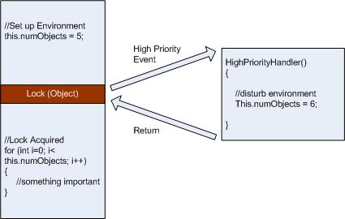

Most of the time that’s the right thing, but there’s also times in Avalon where such unexpected reentrancy can really screw things up. So, at certain key times, Avalon calls Dispatcher.DisableProcessing(), which changes the lock instruction for that thread to use the WPF reentrancy-free lock, instead of the usual CLR lock.

The locking behavior of the CLR has been, to say the least, a controversial issue, so why did the CLR team choose this behavior? It had to do with COM STA objects and the finalization thread. When an object is garbage collected, its Finalize() method is run on the dedicated finalizer thread – not the UI thread. And therein lies the problem, because a COM STA object that was created on the UI thread can only be disposed on the UI thread. So the CLR does the moral equivalent of a Dispatcher.BeginInvoke (in this case using Win32’s SendMessage). But if the UI thread is busy, the finalizer thread is stalled and the COM STA object can’t be disposed, creating a nasty memory leak. So the CLR team made the tough call that in order to fix these really nasty leaks, they had to make locks work the way they do. Chris Brumme’s blog has some really interesting stuff on this, see http://blogs.msdn.com/cbrumme/archive/2004/02/02/66219.aspx. The trick for us Avalon folks has been how to avoid unexpected reentrancy without reintroducing the memory leak, which is why we don’t block reentrancy everywhere.

Conclusion
If nothing else this paper probably taught you that multi threaded Avalon applications are complicated. Avoid them when you can! If you program with Avalon long enough you’ll undoubtedly run into situations where multiple threads are needed to keep the quality of your application high. Hopefully the explanations and examples in this paper will help you build the clear, efficient solutions you’re looking for.

Tyler Barton joined Microsoft in 2005 as a program manager intern on the Windows Client Platform team working on Avalon. He is responsible for xaml error messages, “element services” documentation, and component authoring guidelines, among other things. In his free time he enjoys favourite passtimes are playing basketball and cooking. Tyler attends the University of Waterloo in Ontario, Canada.

Nick Kramer joined Microsoft in 1998 as a developer in Windows Forms. Today he is a program manager on the Windows Client Platform team working on Avalon. He is responsible for the Avalon "element services" technologies, which include threading, the XAML parser, property engine and style system, interop, and input/commanding. After-hours he can be found in the great outdoors hiking, bicycling, or snowboarding. If you have questions about Avalon and Windows Forms interop, you can contact Nick at nkramer@microsoft.com.

